Jesus Clarifies New Age & A-444.4 Tuning
November 6, 2017
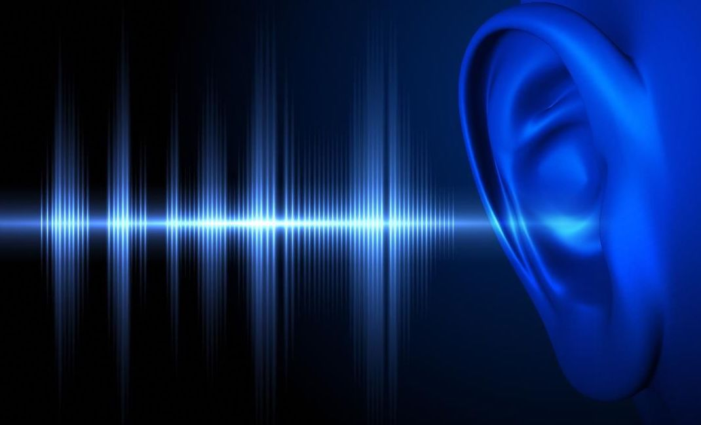
Jesus, please give us the grace and discernment to go deeper when people denounce other Christians, that we might seek the truth for ourselves and not rest on opinions that could be faulty. Amen

Well, my dear ones, I am going to do my very best here to be very objective. I have my own opinions but I prefer to lay them at the feet of Jesus. Nonetheless, I am human and I don’t want my opinions to bleed into what the Lord is telling us. So, I'm praying for help.

I brought this to Him, and I said, "Lord, it is very grievous to me when people make remarks like, a particular instrument tuning they are not culturally familiar with is “New Age” of Satan—even though the evidence is scientific, not just opinion. Lord, please help me come to terms with this."

He began, "These are the same ones who rejected Heidi Baker and left her with no resources for the African orphans, because she was mightily touched by My Spirit at the Toronto blessing.

"Clare, do not concern yourself with these things; they are empty arguments being parroted and repeated, because they listened to someone convincing on the Internet. So they buy it hook, line and sinker and do not bother to check out the science of sound waves, nor the real history of these unusual tunings.

"They have are victims of an impressionable mind that does not inquire past the surface. If they would do their own research and not swallow every opinion on the Internet, they would soon find out there is nothing "new age" or harmful about taking advantage of the different properties of different tunings and it does, over time, have a psychological impact.

"I look at the heart of the musician. If they choose a tuning and they are singing to Me or about Me, I am pleased and blessed, no matter what tuning. It’s the heart that counts. And as you well know, I can take a secular song and turn it into a love song for My Bride. It is the heart that counts. The science is secondary.

"However, I must say that the Israelites followed My instructions to the priests about how to bring the walls of Jericho straight down. That should tell anyone that music has sound waves, sound waves can shatter glass and sound waves can bring down walls and do many other things, such as convict the guilty with a lie detector machines. That is because energy, in the form of sound and electricity, can be measured—and when a person lies, it sets off a certain spike of energy that points to their guilt.

"The Ancient Fathers used different tunings for liturgical celebrations and limited their use of those to praising Me and giving Me glory. Just as it is not acceptable to use sacred incense for common purposes, such as fragrancing a beard. These fragrances are used in the sacrifices offered to Me and they are best to be kept separate from those that you would burn for clearing the air of noxious odors or personal beauty.

"Just as you do not play our trysting music for a background environment, just as you keep that special just for you and I—so were certain instruments and tunings set aside for holy purposes, only. This is nothing new.

"Someone takes an ancient principal and makes a business around it making all kinds of claims. Taking a concept that is foreign to a culture but was in practice hundreds of years ago and repackaging it, is very American. I wouldn’t believe everything I hear or read, but it is nonetheless true that different sounds have a different effect on matter. This is a proven, scientific fact. You are composed of constantly moving particles; you are not solid and insert. You have life."

And then He quoted Colossians 1:16-17 to me: “For in Him all things were created, things in heaven and on earth, visible and invisible, whether thrones or dominions or rulers or authorities. All things were created through Him and for Him. He is before all things, and in Him all things hold together.”

Jesus continued, “'In Me all things hold together' is present tense. It is an ongoing process.

"Life in atoms, molecules, etc. are constantly moving, and it is My Love which holds the Universe together—in ME all things hold together. And the energy which is produced from My Love has Life Force and can be measured in electrical magnetic terms. That does not make it any less holy, for all life comes from Me and is sustained by Me and that makes it holy. Until the enemy perverts it and uses it for unholy purposes.

"These who persecute new concepts in the church are very insecure and lacking in discernment, for it is by the fruit that you know a tree. Look at how many still condemn tongues as coming from the Devil. Those who still accuse Heidi Baker of being "new age" because they operate in the spirit differently than they do, in a way unfamiliar to them or their parents or pastors, and are not taught properly about discernment. Rather, they are taught the norms of their culture and anything out of 'their' norm is suspicious. I would grant them the space to investigate for themselves, but they don’t. They condemn, because someone else condemned and didn’t get to the bottom of it.

"Everything in this universe is vibrating, Clare, and responds to frequencies; those things REFLECT My presence in them. Where the New Age movement has gone wrong, is they do not acknowledge My power, but the power of the reflection. So, rather than draw from the Source, they draw from the reflection, which of itself is only empowered by Me to a very limited extent.

"Why would you use stones to heal, when you could ask Me and I would immediately heal? Do you see? The stars have vibrations, the powers of electromagnetic energy between planets is a fact. You know that the tides of the ocean respond to the energy of the moon in its different phases. And these discoveries of properties of created matter became their god when they forget I created them—and in and of themselves, without My love and ongoing empowerment, they would instantly disappear.

"Now that IS idolatry, secular humanism, witchcraft and New Age.

"Some will even accuse you of being New Age because you observe the moon’s phases in order to know the tides, even though you don’t turn to the moon and worship it, you are merely measuring its physical effect on water. Some do worship the moon—and that is pagan.

"People can be quick to assign hidden meaning and significance to something as simple as changing an instrument’s tuning, because they are not familiar with the science and have not researched it. So, it’s suspect of being New Age, in spite of the ways in which they were used in religious worship, for hundreds of years. And I might add, in spite of the lyrics, which glorify Me!

"How can this be? The Universe has an order and a harmony and there are thousands of different tunings, Clare. That’s why, when people come to Heaven, they hear sounds they have never heard before. But who would accuse Heaven as being "new age"???

"Now, the fruit of Heidi and Roland Baker is the greatest revival in the history of Africa. It is plain to see the conversions: souls that eagerly would die for Me, souls that were witches turned to Me and repented. Whole cities and villages have turned to Me, worship Me and study My Word and serve their fellows.

"A good tree cannot bear bad fruit.

"But a bad tree does not bear good fruit, and you will find many so-called Internet prophets who demean the movements of My Spirit and call it New Age and witchcraft. This is done because they have no discernment. But they will bear the mark of having blasphemed My Holy Spirit for eternity.

"Yet, they call themselves My servants and spend hours figuring ways to discredit innocent people with good fruit. Their fruit is a bitter, because the root is bitter. They draw an audience from discontented and bitter people, who feed on the filth of false accusation, lies and gossip. Where are the miracles, the healings, the conversions, the churches and the Bible studies? They have none.

"I am not saying they are all bad. None of My true believers are all bad. But the Pharisees were not all bad—yet the fruit they bore has gone down in history as a testimony against them.

"Clare, you must teach our audience to discern good from bad fruit and to never repeat a bad report. But if something is suspect, make it an object of study to get to the Truth, or refrain from commenting. But DO NOT parrot people who have no discernment skills and slander the innocent.

"I know you are grieved—as I am, too. But don’t let that steal your evening, please? We still have much to do.

"I am the Author of all life and vibration comes from Me, not an object on its own; it is giving off a pattern of vibration which I have given it. The issue is making the tuning into a god: that is idolatry. But using the tuning and acknowledging Me as the Source is perfectly legitimate.

"It is the same way with gravity and the principals of flight. If you have a glider with a certain amount of span to catch the wind, you can fly. Eventually you will land, but you are using the principals of gravity and physics—harnessing it to fly, because that is the assigned order of the Universe. You don’t worship the glider or assign it as your God and the source of flight; it is merely a tool in harmony with the physical properties I have established.

"In the same way, using a tuning to create a certain atmosphere. The tuning has wavelength and affects matter in a certain predictable way. So, someone who is playing those frequencies can expect the same result each time, because they are tapping into the laws of physics, which I created on Earth.

"Now, when it becomes New Age is when the person begins to assign motives, apart from Me, to the vibration.

"No, that vibration is an expression of My Heart and all glory and honor should be given to Me. But if a non-believer practices these things independent of acknowledging Me, they are simply using the rules and parameters I set in place to obtain the same result. And those results are predictable.

"Where the New Agers go wrong is in not ascribing that frequency and its affect to Me, and not worshipping Me—but making that frequency the object of worship.

"Here is a more common example. A doctor prescribes a medicine to cure an infection. He is using scientific data in such a way that it will cure an illness; it has a proven track record of killing that bacteria. Where the doctors go off track is in saying that they don’t need God; the realities of scientific evidence are their god. I am still Sovereign over life and death. I can easily block the qualities of the medicine so the person will not get better.

"I am God and there is none other.

"So, My dear ones, be careful to never ascribe science to New Age. It is the way it is used, it is a tool. I am the Source—if it is a replacement for Me, it is Idolatry. If it is used the way it was created and intended, to worship and give Me glory, it is merely a tool in the hands of a Christian.

"By their fruits, you will know them."

